Project 2 Report

Overview
For this project, I chose to solve the producer-consumer problem, where producer threads adds items to a buffer and consumer threads remove items.

Implementation Details
Before doing any thread scheduling, my program first obtains thread info from a user-specified file and stores that info in an array of ProcessThread objects, which, among other things, contains each thread’s PID, arrival time, burst time, priority value, and signifier of whether or not said thread is a producer or consumer thread. These threads are then started via the Thread.start() function one after the other by looping through the array. Arrival times and CPU burst times were simulated using the Thread.sleep() function. To keep only one producer and consumer thread from running at a time, I utilized Semaphore objects. Namely, I created Semaphore objects named canRead and canWrite that each have one permit, so that only the first consumer and producer thread can, respectively, acquire a permit from them, forcing other thread to block until the first threads release permits back to the semaphores. Additionally, I created Semaphore objects named full and empty to simulate the f and e semaphores typically used to track the number of full and empty buffer slots. These semaphores prevent consumer threads from reading from empty slots or producer threads form overwriting full slots.

Results
My tests for my program utilized the following processes.txt file:
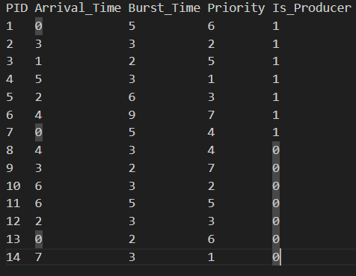
Using this data, processes finished in the following order during my sample run:
1 → 13 → 7 → 3 → 12 → 9 → 5 → 8 → 2 → 11 → 6 → 10 → 4 → 14

Challenges & Solutions
One challenge I encountered was determining how producer threads would generate data for the buffer. The solution I came up with was to utilize the Math.random() function to randomly select characters from a premade array and combine them into a string to place into a buffer slot. Another challenge I encountered was how to signify whether a thread was a producer or consumer thread. The solution I devised for this problem was to pass an integer signifying as such during creation of a ProcessThread object. If said integer had the value of 1, an attribute for the object named isProducer would be set to true; otherwise, it would be set to false.

